**How to add image in title bar aka Favicon!**

**Step 1:**  
Code a simple scripting. Sample below. Then saved it. I saved it as ***test.html***

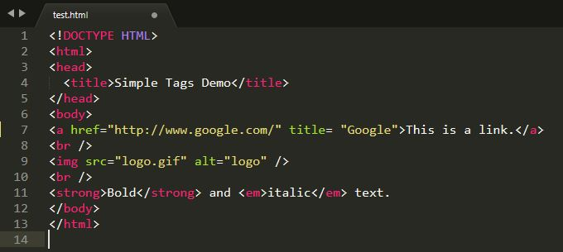

**Step 2:**

Run the ***test.html*** file. The output will be liked:

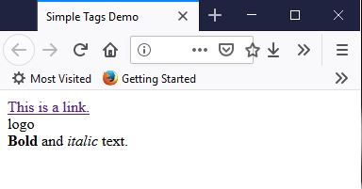

You will be seeing a webpage without icon in the Title bar, right?

But...you want to create something like this (with your own icon/image/favicon):

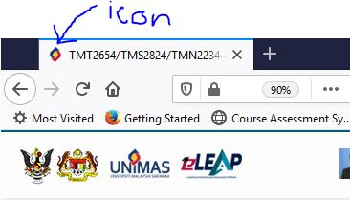

**Step 3:**

*Note: The <title> only supports plain text. You will need to create an.ico image with the filename of favicon.ico (save as any name) and save it into the root folder of your site (where your default page is).*

*You can create your own ico file using GIMP or Photoshop. As for me, I just find any free website that offer free ico file to download. You can click here for sample >>*[*CLICK ME*](http://www.softicons.com/free-icons)*<<*

Icon that I chose and used for this example as below (saved it as ***doc.ico***):

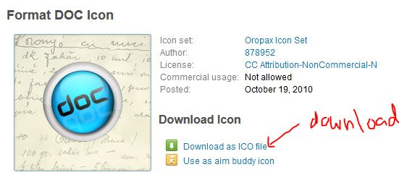

Now, add on this syntax in your scripting (place it in *<head>* section):

***<link rel="shortcut icon" href="doc.ico" />***

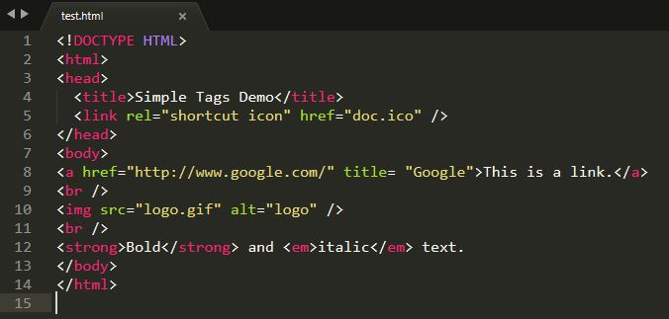

**Step 4:**

Saved and run your ***test.html***

Your output be liked:

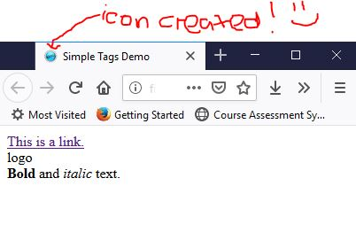

Enjoy scripting & Have fun! 😊